Brooklyn torah gazette
For yom tov shavuos 5782
Volume 6, Issue 36 (Whole Number 291) 6-7 Sivan/ June 5-6, 2022

Burnout, Shavuot and
Living with Purpose
By Rabbi Benjamin Blech

Pursue meaning, not happiness.

It’s official. Last week the World Health Organization just concluded that the official compendium of diseases needs to include one more common contemporary disease under its list of sicknesses to be taken seriously by the medical profession.
Burnout has been upgraded from a “state of exhaustion” to a “syndrome” – which means that a truly significant number of people are not just sick of their jobs and sick of their lives; they are sick in the literal sense, ill mentally, emotionally and physically to the extent that their condition requires professional attention.
Perhaps this new phenomenon can shed on a famous biblical story, a seminal event in the life of Moses which may have much greater meaning than commonly understood at first reading.
Moses' first encounter with G-d took place at a bush. Bush in Hebrew is called sneh. Commentators claim that very spot would be the location for the giving of the 10 Commandments. From the word sneh comes the word Sinai. The holiday of Shavuot and the giving of the Torah are inextricably linked with the scene of the miracle shown to Moses. A bush burning with fire was strangely not consumed.
Superficially it was simply the scene of a miracle. It was G-d demonstrating his supernatural power. It was the prelude to G-d asking Moses to assume the heavy burden of leadership. Yet the question begs to be asked: Could not G-d have performed a more amazing feat than this? Surely there must’ve been some greater meaning to this particular miracle. Indeed, the specific nature of the miracle must have also been a sign and a message.

Having a life filled with meaning and purpose, is the best way to never suffer from burnout.
Permit me to suggest that G-d was giving Moses a powerful answer to the very same problem currently identified as key to contemporary culture. A bush was burning – yet it was not consumed. So too, G-d assured Moses, doing G-d’s will, having a life filled with meaning and purpose, is the best way to never suffer from burnout.
The “burning bush” is not so much the story of a miracle as it is a vivid depiction of the miracle of lives filled with fiery passion for a greater cause.
Burnout, psychologists tell us, is apathy, akin to the feeling that life has no meaning. There is a crisis of purpose in our world today. People feel overwhelmed, lonely, and unfulfilled. In chasing the “good life,” they have sacrificed their relationships, their health, and, at the end of the day, still find themselves with lives and work that bring them little joy and meaning. Depression is on the rise and many people can’t cope with the pace of change brought on by technological, cultural, and social transformations. Some turn to drugs and other forms of avoidance, some put on a happy face to mask the issues, while others simply withdraw and postpone living a full life. Many people feel like they are “prisoners” in their own lives.
Viktor Frankl, the world-renowned psychiatrist, existential philosopher, and author of the classic bestseller, Man’s Search for Meaning, described it brilliantly. People today, he said, are living in an existential vacuum. Vacuums need content - and the content must be purpose.
In The Power of Meaning: Crafting a Life That Matters Emily Esfahani Smith reviewed hundreds of empirical papers from the growing body of research on meaningfulness and found that the defining features of a meaningful life are connecting and contributing to something beyond the self. Meaningful activities generate positive emotions and deepen social connections, both of which increase our satisfaction with life. Research shows that focusing on happiness in life is actually self-defeating. Helen Keller put it well: “Many persons have a wrong idea of what constitutes true happiness. It is not attained through self-gratification but through fidelity to a worthy purpose.”
The most motivating choices are ones that align with our “why” and our purpose. Christine L. Carter Ph.D., a sociologist and happiness expert at UC Berkeley’s Greater Good Science Center, and author of The Sweet Spot: How to Find Your Groove at Work and Home explains:
“Compelling research indicates that the pursuit of happiness – when our definition of happiness is synonymous with pleasure and easy gratification – won’t ultimately bring us deeper feelings of fulfillment; it won’t allow us to live in our sweet spot. Although we claim that the “pursuit of happiness” is our inalienable right and the primary driver of the human race, we humans do better pursuing fulfillment and meaning – creating lives that generate the feeling that we matter.”
In her research, Iris Mauss, a social psychologist at U.C. Berkeley who studies the possible negative consequences of seeking happiness, found that people who place a great value on being happy actually have more mental health problems, including, sadly enough, depression. The more value you place on your own happiness, the more likely you are to feel lonely. “Wanting to be happy can make you less happy.
If you explicitly and purposely focus on happiness, that appears to have a self-defeating quality. Don’t spend your valuable time seeking your own happiness. You will end up feeling more shallow than you can ever imagine. Pursuing meaning, however, makes you feel good about yourself, because you are pursuing something bigger than yourself. Something that makes you come alive.”
The holiday of Shavuot recalls the single most important moment in of all of human history. At Sinai we were given a call to make our lives filled with meaning. We were given the commandment that our lives must have purpose – and the pursuit of that purpose would ensure far greater joy than the pursuit of happiness.
Sinai reinforced the message of the sneh, the burning bush. In making our lives meaningful we have found the divine response to the dreaded disease of burnout.

Reprinted from the 2019 Shavuot website of Aish.com

Trustees of Torah

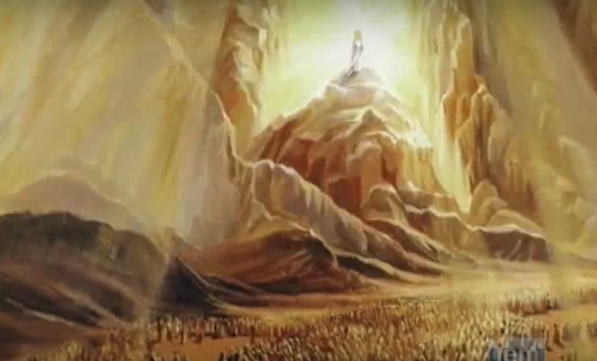

Shavuos celebrates the Giving of the Torah at Sinai. Jews in every generation gather to hear the reading of the Ten Commandments, for on this day they receive renewed strength in their mission to brighten G-d’s world.
Shavuos celebrates the Giving of the Torah at Sinai. Jews in every generation gather to hear the reading of the Ten Commandments, for on this day they receive renewed strength in their mission to brighten G-d’s world.
This applies to Jewish children in particular, for G-d did not agree to give His Torah to the Jewish people until they offered their children as its guarantors. Jewish children are thus especially empowered on this day to grow not only in their own relationship with G-d, but to nurture their friends’ and family’s relationships with G-d as well
When life’s challenges get tough, the first Commandment reminds you of the secret to the Jewish people’s survival and success throughout exile: “I am the Lord, your G-d, Who took you out of the land of Egypt” – the Creator of the universe Himself is standing by your side to deliver you from your every personal challenge in life, and ultimately the entire world from the exile itself.

Reprinted from the Shavuos 5782 website of Chabad.Org
21 Things the Torah
is Compared To
By Yehuda Shurpin

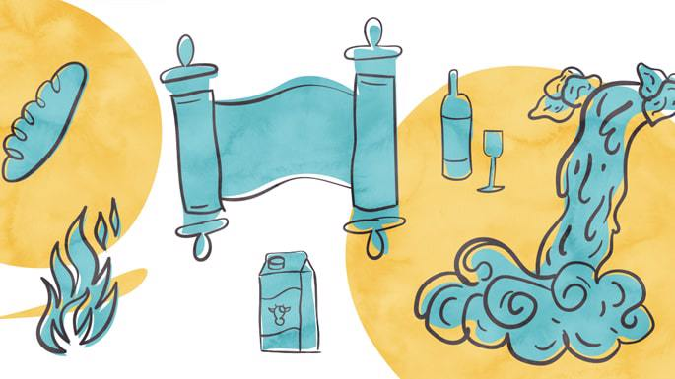

The Torah is multifaceted, and so it makes perfect sense that Scripture and the sages employed a range of metaphors to describe different aspects of the Torah. Below is a list of 21 things Torah is compared to.
(Note that this list is far from exhaustive, and that although some items may be comparable to Torah in multiple ways, we generally just listed one or two.)

1. Water
Perhaps the most common metaphor for the Torah is water. The verse states, “Ho, everyone who thirsts, come for water.”¹ The Talmud explains that water is a reference to Torah.²
Another comparison: just as a fish cannot live out of the water, so too the Jewish nation cannot exist without the Torah.³

2. Wine
Just as wine gladdens the heart, so too does learning Torah. And just as wine becomes better as it ages, so too the Torah that we learn and retain in our minds becomes more enhanced as time progresses.⁴

3. Oil
The Torah brings light into the world like oil. Just as with olive oil, the more it is crushed the better it becomes, so too the more you go over any topic in Torah, the better your understanding becomes.⁵

4. Light
The Torah is called light,⁶ for it enlightens the person regarding what he should do⁷ and brings light into the world.

5. Milk
Just as milk keeps best in cheap utensils and spoils quickly in silver or golden utensils, so too the Torah remains with humble people and is repelled by the arrogant.⁸

6. Honey
In addition to the Torah being sweet like honey,⁹ it is significant that honey is made by bees.
Honey originates from a source that is spiritually impure, i.e., not kosher, yet after the product is developed, it is pure and fit for human consumption. Thus, Torah is compared to honey because of its power to elevate and purify even one who has fallen into a state of spiritual contamination.¹⁰

7. Bread
Physical bread nourishes the body when it is ingested and absorbed within it, when it is transformed into one’s own blood and flesh. Similarly, when the soul comprehends and joins with the Torah, the Torah then becomes food for the soul.¹¹

8. Fire
Scripture compares Torah to both fire¹² and water (see above). The second Rebbe of Chabad, Rabbi DovBer, would explain that the “revealed” Torah—the practical, legal teachings of Talmud and halachah—is called water, whereas the “inner” Torah—the esoteric and mystical teachings—is called fire. Now, people are attracted to water, but they fear fire. Thus, the one who teaches the inner dimension of Torah must assure his pupil, "Do not fear, for 'The L-rd your G-d is a consuming fire.'¹³”¹⁴
9. Bee
Just like a bee, whose honey is for its owner but it stings others, so too the Torah is sweet for those who learn it but stings those who transgress it.¹⁵

10. Goad
Just as a goad (used to direct cattle) drives the ox to the field where it will produce life-sustaining food, so do the words of Torah direct those who study them to “the paths of life.”¹⁶

11. Wood
The Torah is likened to a tree,¹⁷ for just as a small piece of wood can ignite a large piece, minor Torah scholars can sharpen great Torah scholars and enable them to advance in their studies. As Rabbi Chanina said: “I have learned much from my teachers and even more from my friends, but from my students I have learned more than from all of them.”¹⁸

12. Fig Tree
Unlike many other fruits, figs don’t all ripen at the same time on a tree, and they need to be picked slowly day after day. So too Torah is acquired by learning it day by day.¹⁹

13. Bird
Just as a bird has a sweet voice, so too the sound of Torah is sweet.²⁰

14. Nut
A nut has a hard shell on the outside and is softer on the inside. Likewise, the outer part of Torah is the doing of the mitzvahs, and the inside contains the multiple layers of meaning and ways of explaining the Torah.²¹

15. A Loving Doe
Just as a doe is beloved by its mate at every moment, so too the Torah is beloved by those who learn it every moment just as the first time they learned.²²

16. Kings
Just as a king has the power of life and death, so too the Torah has in it the power of life and death.²³

17. Pillars
Just as pillars hold up a building, so too the Torah is the pillar that supports the world.²⁴
18. Fragrance
Just as one who enters a shop that sells fragrances leaves with a fragrant scent, so too, being around Torah learners will rub off a “sweet scent” onto you.²⁵

19. Rain
Just as a steady rain can erode a strong rock, so too Torah can soften the hardest of hearts.²⁶

20. Salt
The mystical aspects of the Torah are compared to salt,²⁷ while the revealed aspects of the Torah are compared to bread and meat. Just as salt doesn’t have much of a taste on its own, but gives taste to the meat and bread, so too the mystical aspects of the Torah may not always be fully comprehended, but they add taste and flavor to the rest of the Torah.²⁸

21. Sword
A sword, if you know how to use it, will not injure you. Likewise, if you know how to expound upon Torah, it will not cause you harm. But if you don’t know the rules of how to expound upon it, but do so anyway, it can cause you harm.²⁹

FOOTNOTES
1. Isaiah 55:1. 2. Bava Kama 82a. 3. Berachot 61b 4. Sifri, Eikev 48.
5. Tanchuma, Ki Tavo 3. 6. Proverbs 6:23. 7. Bamidbar Rabbah 14. 8. Taanit 7a.
9. See Song of Songs 4:11 10. Se Olelot Ephraim. 11. Tanya, Ch. 5.
12. Jeremiah 23:29 13. Deuteronomy 9:3. 14. Hayom Yom, 16th of Av.
15. Devarim Rabbah 1:6. 16. Chagigah 3b. 17. Proverbs 3:18 18. Taanit 7a
19. Bamidbar Rabbah 12:9 20. Zohar 1:92. 21. Zohar, Ruth, 376. 22. Eruvin 54b.
23. Yalkut Shimoni, Mishlei 940. 24. Bamidbar Rabbah 10:4.
25. See commentary of Rabbi Ovadia of Bartenura on Avot 1:4.
26.,Tanchuma, Haazinu 3. 27. See Sofrim 15:8. 28. Likkutei Torah, Vayikra 5d.
29. Yalkut Shimoni, Devarim 951.

Reprinted from the current Shavuot 5782 website of Chabad.Org

